**Business Rules for Data**

<https://www.pro-football-reference.com/boxscores/201710290buf.htm> - Scroll down to Full Play by Play table at bottom.

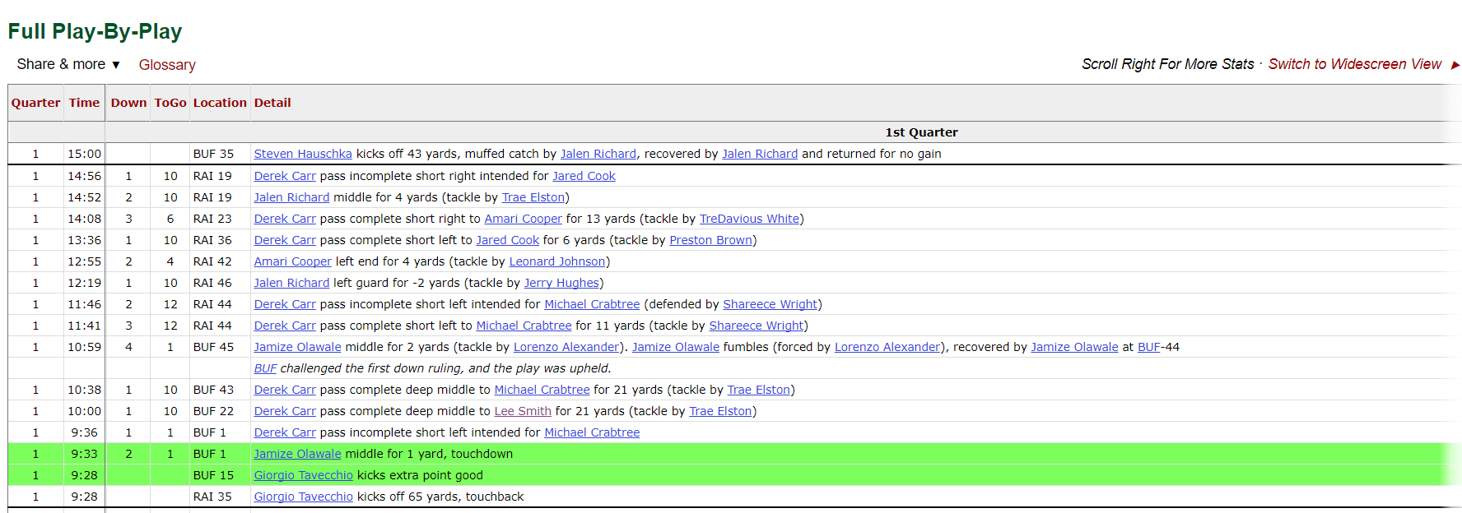

GENERAL

Every Play needs to record as a:

1. **By Game** Player Stat (‘NFLPlayer’ table) AND NFL Team Stat (‘NFLTeam’ table)
   * NFL Player Stat – The Player Name(s) associated with the play will get the statistics based on the rules below. We will need a Lookup Table to summate/aggregate the Player data as Team Stats.
   * NFL Team Stat – The NFL Team that the NFL Player is on will get the statistics based on the rules below.
2. **By Quarter/ By Half**: Every Play needs to record the statistics by the Quarter, and Half as well.
   * Quarter indicator is defined by a numeric value on the far-left column (1-4, and “OT” if Overtime)

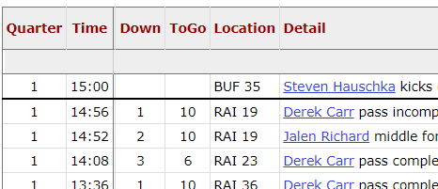

* + For each record (cell) mapped below, we need to have the ending for each quarter as well. For example – IF a player gets a ‘rushingattempts,’ for the game, he will also need to get the quarters ‘rushingattempts1q,’ ‘rushingattempts2q,’ … ‘rushingattempts2h,’ ‘rushingattemptsovt’ …

1. **Redzone Plays:** When the team with the football is on the opponent’s side of the field, inside the 20-yard line. On the table there is no indicator for what team is in possession of the ball.
   * Redzone Plays *might* need a NFL Player lookup table to determine The NFLPlayer Current Team

**Example of Redzone Problem** – The following two examples show the issue in identifying the Redzone Plays. Both examples are inside the 20-yard line, but there are no indicators on what team has the ball.

* + These *are* Redzone Plays, because BUF has the football inside the RAI 20



* + These *are Not* Redzone Plays because RAI has the football inside the RAI 20



1. **Player AND NFL Team Stats By Redzone, By Quarter**
   * These values will be in the **NFLPRZ** table**.**
   * To display all the stats by each quarter that occurred in the Redzone.
   * For each record (cell) mapped below, we need to have the ending for each quarter, *BY Redzone*, as well. For example – IF a player gets a ‘passingattempts,’ for the game, he will also need to get the quarters ‘passingattempts1q,’ ‘passingattempts2q,’ … ‘passingattempts2h,’ ‘passingattemptsovt’ …

All data-mapping below will need to be accounted for the requirements above.

RUN PLAYS

**Indicator**: Run plays are determined by the word “right” OR “left” OR “middle” after the (first) player name.



1. The (first) player name gets 1 ‘rushingattempts’ and the total yards, listed as ‘rushingyards’’
   1. Jalen Richard = 1 rushingattempts, and 4 rushing yards
2. The (first) player name gets a 1 ‘rushingtouchdowns’ and the total yards, listed as ‘rushingyards’
   1. Melvin Gordon = 1 rushingattempts, 87 rushingyards and 1 rushingtouchdowns

PASS PLAYS

**Indicator:** Pass Plays are determined by the word “pass” after the (first) payer name.



1. For all Pass Plays the (first) player name gets 1 ‘passingattempt’ and the (second) player name gets 1 ‘target’
2. For all Pass Plays where the words “pass complete” are after the (first) player name gets 1 ‘passingcompletions’
3. For all Pass Plays where the words “pass complete” are after the (first) player name gets the total yards listed, as ‘passingyards’
   1. Derek Carr = 11 passingyards
4. For all Pass Plays where the words “pass complete” are after the (second) player name gets the total yards listed, as ‘receivingyards’
   1. DeAndre Washington = 11 receiving yards



1. The (second) player name gets a 1 ‘receivingtouchdowns’ and the total yards, listed as ‘receivingyards’
   1. Rob Gronkowski = 2 receivingyards and 1 receivingtouchdowns

Extra Points

**Indicator**: Extra Points are determined by the words “kicks extra point” after the (first) player name, and immediately follows a touchdown

1. For all rows with the words “kicks extra point” the (first) player name gets 1 ‘extrapointsattempted’
2. For all rows with the words “kicks extra point good” the (first) player name gets 1 ‘extrapointsmade’
   1. Nick Novak = 1 extrapointsattempted and 1 extrapointsmade
3. For all rows with the words “kicks extra point no good” the (first) player name only gets 1 ‘extrapointshadblocked’

FIELD GOALS

**Indicator**: Field Goals are determined by the words “field goal good,” “field goal no good,” or “field goal blocked” after the (first) player name

1. For all rows with the words “field goal” the (first) player name gets 1 ‘fieldgoalsattempted’
2. For all rows with the words “field goal good” the (first) player name gets 1 ‘fieldgoalsmade’ and the total yards will be classified into one of the following: ‘fieldgoalsmade0to19’ or ‘fieldgoalsmade20to29’ or ‘fieldgoalsmade30to39’ or ‘fieldgoalsmade40to49’ or ‘fieldgoalsmade50plus’ or ‘fieldgoalsmade60plus’
   1. Mike Nugent = 1 ‘fieldgoalsmade’ and 1 ‘fieldgoalsmade40to49’
3. For all rows with the words “field goal no good, blocked” the (first) player gets 1 ‘fieldgoalshadblocked’

DEFENSIVE PLAYS

1. The player listed after (“tackle by” …) gets 1 ‘solotackles’ AND 1 ‘tackles’



* Jerry Hughes – 1 ‘tackles’ AND 1 ‘solotackles’

1. IF “(tackle by PLAYER1 and PLAYER2)” exists, Do Not Follow Rule #1 (Above) - The first player listed after (“tackle by” …) gets 1 ‘tackles’ and the second player listed after (“tackle by” …) gets 1 ‘assistedtackles’



* Matt Milano gets 1 ‘tackles’
* Adolphus Washington gets 1 ‘assistedtackles’

1. The player listed after (“defended by” … ) gets 1 ‘passesdefended’



* Shareece Wright gets 1 ‘passesdefended’

1. If the word “fumbles” exists, the player *before* the word “fumbles” gets 1 “fumbles”



* Jalen Richard gets 1 ‘fumbles’

1. If the words “forced by” exists, the player *after* the word “forced by” gets 1 “fumblesforced”



* Matt Milano gets 1 ‘fumblesforced’

1. If the words “recovered by” exists, the player *after* the word “recovered by” gets 1 “fumblesrecovered”



* Mike Tolbert gets 1 ‘fumblesrecovered’

NOTE – In order to determine if the ‘fumble’ is a ‘fumblelost’ we need to determine the NFL Team the Player (who fumbled) is on – AND the Team of the player who recovered (‘fumblesrecovered’) is on. The PlaybyPlay table does not have this information 🡪 do we need a Lookup table for all NFL players?

1. If the words “intercepted by” exists, the player *after* the word “intercepted by” gets 1 “interceptions”



* Trae Elston gets 1 ‘interceptions’

1. If the words “intercepted by” exists AND “and returned for”, the player *after* the word “returned for” gets 1 “interceptionreturnyards” for the number of yards listed after “returned for”



* Trae Elston gets 22 ‘interceptionreturnyards’

1. If the words “intercepted by” exists the (first) player gets 1 “passinginterceptions”



* Derek Carr gets 1 ‘passinginterceptions’

OTHER INFORMATION

1. If “Timeout” exists in a Row – Ignore record



1. If “(no play)” exists in a Row – Ignore record



1. If “upheld” exists in a Row – Ignore record of that Row



1. If “overturned” exists in a row – Ignore the Row above



* The example above – The top Row Play does not count.
* The actual play starts after the word “overturned”

NEEDED STILL

* Turnovers for Touchdowns
* Returns for Touchdowns
* Punts
* Kick/Punt Returns